Operation Gunnerside - the Telemark raid

28th February 1943: Norwegian troops trained by the Special Operations Executive succeed with 'one of the most important sabotage raids ever'
FEB 28

SAVE |  | ▷ LISTEN

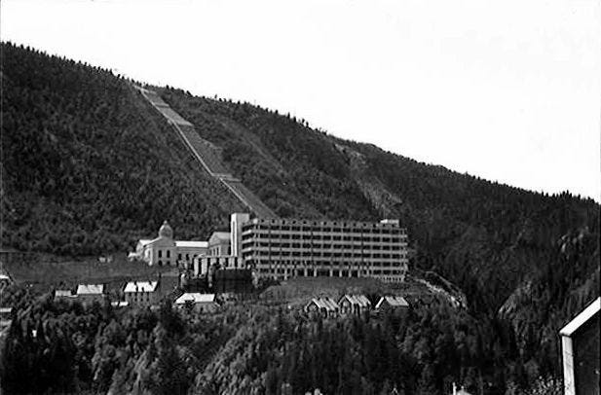
Vemork hydroelectric power plant at Telemark in 1935. The process for producing heavy water took all seven stories of the front building, the final product was accumulated in tubs at the bottom.
When the British learnt that the Nazis had embarked on an atomic weapons programme they were prepared to take considerable risks to disrupt it. The main target was the Norwegian hydroelectric plant which was producing 'heavy water' - essential for the Nazis to progress with their programme.
In late 1942 they had dispatched Operation Freshman. This attempt to mount an armed raid on the facility at Vemork had ended in disaster when one plane and two gliders carrying Airborne Division troops had crashed in Norway. The twenty-three men who survived the crashes were all executed under Hitler's Commando Order¹.
Now the British Special Operations Executive tried again. The advance team for Operation Freshman, four Norwegians who had parachuted into the country before the gliders, had survived the winter by living off reindeer and moss. It was a notable feat of survival. Now they were joined by further Norwegian parachutists for a covert raid on the plant, rather than a military assault.
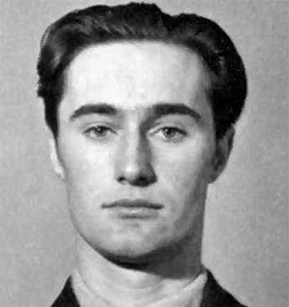
Joachim Ronneberg (1919-2018) continued with other sabotage operations in Norway after this raid. He was later awarded Norway’s highest gallantry award, the War Cross with Sword, the British Distinguished Service Order, the French Croix de Guerre, and the American Medal of Freedom with Silver Palm.
The operation had been hastily arranged and the men had to improvise how they would breach the defences around the plant. By scaling the seemingly unclimbable 600-foot cliffs below the Norsk Hydro, they sidestepped the main German security to gain access on thee night of 27th-28th February.
Joachim Ronneberg² was one of the men who had recently arrived by parachute. He later gave this account of the attack on the plant:
The main building was 25 by 100 metres in seven stories. The production started in the top storey and continued in circles until it ended as heavy water down in the bottom. And that was our target: a battery of 18 cells, the last stage in the production.
Two of us managed to get in and we started laying the charges. The order was that if anything happened that could endanger the result, you had to act on your own. The three other chaps in the demolition party, one of them carrying a set of charges, decided to break the window to get inside because they did not know that we were busy inside. When the window broke, both goups were equally surprised.
I helped one of my friends to get in, and we finished laying the charges. They were not big charges. They weighed about 4.5 kilos, and had been chained up by the British before we left. Two-minute fuses, four of them.
“You just run around the corner, up the staircase, lie down and keep your mouth open, until you hear the bang.”
There was a Norwegian workman inside the factory reading the instruments and filling out the logbook. He heard us talking Norwegian, discussing whether we should put on a 30-second fuse just to be sure that we heard the bang as soon as possible.
That was when he asked for his glasses. It was difficult to get glasses in Norway, so he wanted to have them before we lit the charges. I remember I threw away what I was doing and searched for the glasses and found the case and handed it to him.
He was very pleased and I started getting the ignition sets ready when he suddenly said that the glasses were not in the case. I said "Where the hell are they then?" And he said "Well, they were there when you came in." In the end I found them being used as a bookmark in his logbook, and gave them to him.
Then we ordered him to give us the key for the cellar door so that we could go out through the door like other human beings. We opened the door and I remember Major Tronstad saying that in case we needed to lock up the guard, the key for the lavatory was on the left-hand side of the door. I remember just after we had lit these 30-second fuses, I saw the key, but we did not need it.
We said to the man, "You just run around the corner, up the staircase, lie down and keep your mouth open, until you hear the bang. There will be only one bang, so when it is over you can go down and watch the result". I do not know if he did. But I know that he kept his mouth open, because he could hear when I met him two years later. Otherwise, if he had had his mouth closed he would have blown out his eardrums.
We had planned to meet the covering party down by the river. They expected to be there a while after they heard the bang, not knowing that we had used only 30-second fuses, so we met them just outside the gate.
What astonished us was that the Germans did not understand what had happened at all. The covering party told us that one man came out of the doorway of the guard house with a torch, and made a sort of search around the house and went in again. When we got back across the river, we took a parallel road to the main road leading down to Rjukan centre.
At the place where the funicular starts down in the valley, we began climbing a zigzag road leading up to the top. It was a rise of about six or seven hundred metres, and it took us, I would say, three hours from the explosion until we could put on our skis up on the mountainside.
Hitler’s nuclear programme had been brought to a halt. General von Falkenhorst, the German commander-in-chief in Norway described it as ‘the finest coup I have seen in this war’, even if he described the raiders as ‘British gangsters’.
The raid would later be celebrated in the 1965 film ‘Heroes Of Telemark’ starring Kirk Douglas and Richard Harris. Ronneberg called the film factually flawed. “They took a true story and spun their own idea around it. It should never have been allowed.”
1
The Assault Glider Trust.
2
Based on a presentation by Joachim Ronneberg at the International Conference on Nuclear Technology and Politics, Rjukan 16 - 18 June 1993. Read the full account at Brage.
The 60th anniversary BBC Radio programme is still available online.

